**TELECOM CUSTOMER CHURN ANALYSIS**



**INTRODUCTION:**

In today's fast-paced digital era, telecommunications companies play a vital role in providing essential services like mobile communication, internet access, and entertainment solutions. Telco, a leading telecommunications provider in the United States, offers a wide range of services including telephony, data communication, television, and movie streaming. With an ever-growing customer base, maintaining customer loyalty is crucial for sustaining revenue and fostering long-term growth.

One of the significant challenges faced by Telco is predicting whether a customer will continue using their services or leave (customer churn). Customer churn can result in substantial revenue loss, making it imperative to identify and address the factors influencing customer attrition. By leveraging advanced analytics and interactive dashboards, Telco can gain deeper insights into customer behavior, identify high-risk customers, and implement targeted strategies to improve customer retention.

This project aims to analyse customer data using Power BI, enabling Telco to understand key drivers behind customer churn, predict at-risk customers, and provide actionable insights. With these insights, Telco can proactively design retention strategies, offer personalized services, and mitigate churn, thereby enhancing customer satisfaction and reducing revenue loss.

**PROBLEM STATEMENT:**

Telco, a major telecommunications provider in the United States, faces increasing competition and rising customer attrition rates. Despite offering a diverse array of services, including mobile, internet, and entertainment packages, the company struggles to accurately predict which customers are likely to churn.

Understanding the factors that contribute to customer churn is critical for designing effective retention strategies. Key variables such as customer demographics, service usage, payment methods, and contract types play a vital role in influencing customer decisions. However, without a data-driven approach, Telco cannot effectively identify and retain customers at risk of leaving.

This project addresses the challenge by leveraging Power BI to analyse customer data, visualize key trends, and develop predictive models.

The goal is to empower Telco with actionable insights to:

1. Identify high-risk customers who are likely to churn.

2. Understand the key factors driving customer attrition.

3. Develop targeted marketing and service strategies to reduce churn.

4. Enhance customer satisfaction and loyalty through personalized offerings.

By implementing these insights, Telco can reduce revenue loss, improve customer retention, and maintain a competitive edge in the telecommunications industry.

**PROJECT BACKGROUND:**

In the highly competitive telecommunications industry, customer retention is crucial for maintaining profitability and ensuring long-term success. Customer churn refers to the loss of customers over a specified period, and understanding the reasons behind customer attrition is vital for businesses. This project aims to analyse customer data to identify patterns, predict churn, and develop actionable insights to improve customer retention strategies.

**PROJECT OBJECTIVES:**

* Analyse customer behavior and identify patterns leading to churn.
* Visualize key metrics such as customer tenure, service usage, and contract types.
* Provide actionable insights to enhance customer retention strategies.
* Showcase interactive dashboards for real-time data exploration.

**PROJECT OVERVIEW:**

The Telco Customer Churn Prediction Analysis project focuses on utilizing customer data to understand the factors driving customer churn. By leveraging data analytics and visualization through Power BI, the project identifies high-risk customers, key churn drivers, and provides business recommendations to mitigate churn rates. This project helps the company reduce revenue loss and improve customer satisfaction through data-driven decision-making.

**INSIGHTS & OUTCOMES:**

* Identified top factors influencing customer churn.
* Improved decision-making with interactive, data-driven visualizations.
* Demonstrated the power of business intelligence in customer retention.

**DATA MODELING:**

The data model for this project is designed to optimize performance and facilitate comprehensive analysis. It is structured using a Star Schema approach in Power BI, ensuring efficient querying and visualization of customer churn insights.

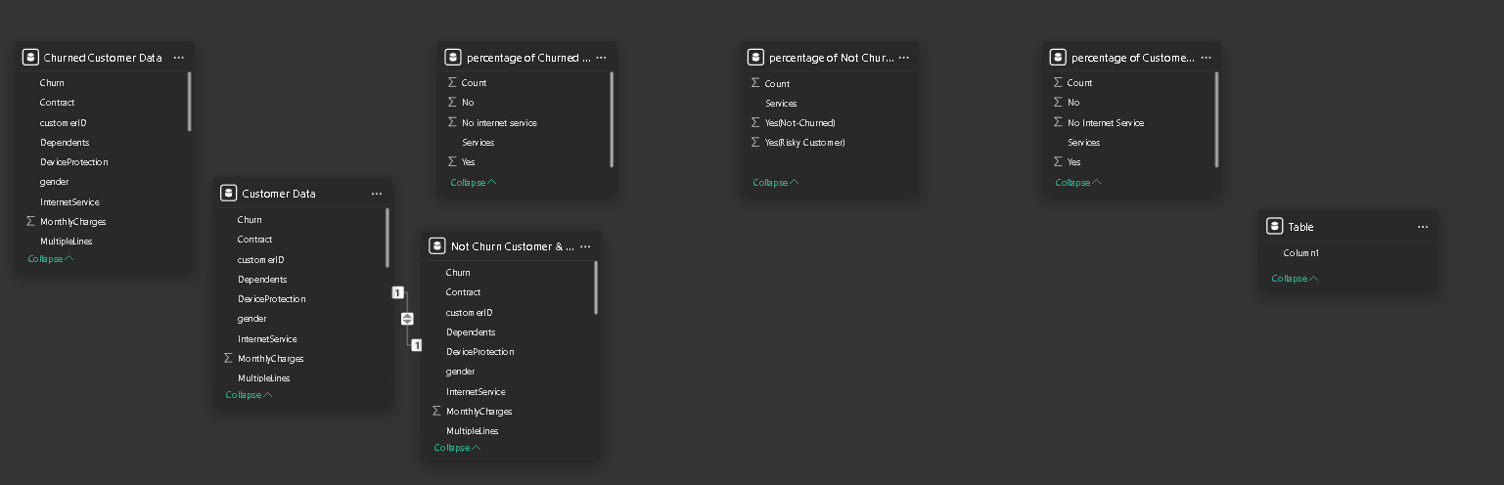

**TABLES AND RELATIONSHIPS:**

1. **Customer Data Table:**

* Contains core customer attributes, including contract type, customer ID, gender, service usage, payment details, and monthly charges.
* Acts as the central fact table, linking related datasets.

1. **Churned Customer Data Table:**

* Focused on customers who have churned, capturing attributes such as service type, gender, contract type, and monthly charges.

1. **Not Churn Customer & Risk Analysis Table:**

* Contains information on customers who have not yet churned, with additional columns for risk classification (High, Medium, Low).
* This table aids in identifying at-risk customers through predictive modeling.

1. **Percentage of Churned Customer Table:**

* Aggregated metrics summarizing churned customers by various categories (e.g., Internet Service, Payment Method).

1. **Percentage of Not Churned Customer Table:**

* Provides insight into customers who remain active, broken down by service type and other demographic features.

1. **Percentage of Customer Data Table:**
   * Offers a holistic view of customer distribution across key attributes, enabling comparative analysis between churned and non-churned segments.

**Relationships:**

* The Customer Data table serves as the primary hub, connecting with the Churned Customer Data and Not Churn Customer & Risk Analysis tables through the customerID field.
* Aggregated tables (Percentage of Churned Customer, Percentage of Not Churned Customer, and Percentage of Customer Data) provide summarized insights and are linked to the core dataset for enriched visualizations.
* This model facilitates an integrated analysis across multiple customer dimensions, supporting both exploratory data analysis and predictive modeling.

**1.Churned Customer Analysis Dashboard Overview:**

This dashboard provides a comprehensive analysis of customer churn, focusing on demographics, customer account information, service subscriptions, and payment behavior.

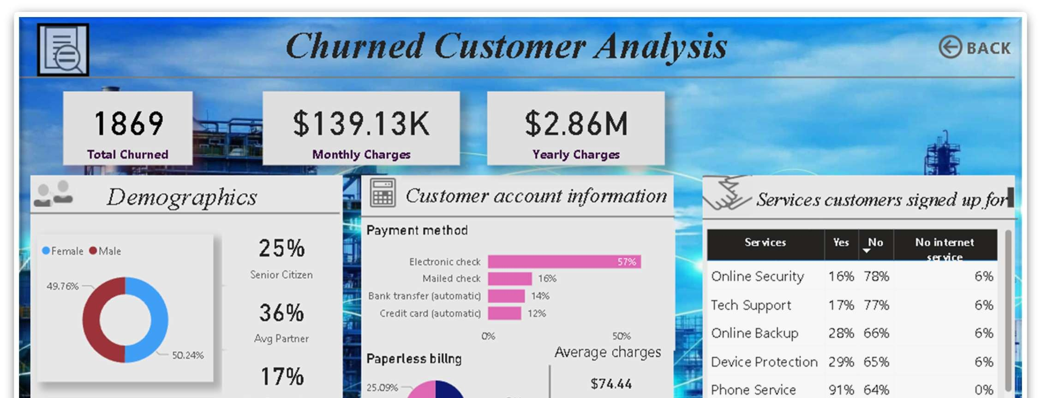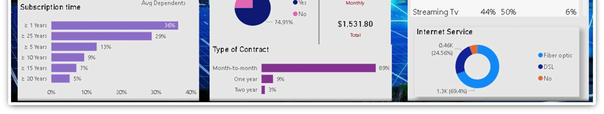

**📈 Visualization Development:**

1. **KPI Cards (Top Section):**

* Total Churned: **1,869 Customers**
* Monthly Charges: **$139.13K**
* Yearly Charges: **$2.86M**

1. **Demographics (Left Panel):**

* Gender Distribution: **Female (49.76%)**, **Male (50.24%)**
* Senior Citizens: **25%**
* Average Partner: **36%**
* Average Dependents: **17%**
* Subscription Time Breakdown: Majority churn occurs within **1-5 years** (65% combined).

1. **Customer Account Information (Middle Panel):**
   1. **Payment Method**: Most churned customers prefer **Electronic Checks (57%)**.
   2. **Paperless Billing**: **75%** of churned customers use paperless billing.
   3. **Type of Contract**: **89%** of churned customers are on a **month-to-month** contract.
   4. **Average Charges**:
      1. **$74.44** monthly
      2. **$1,531.80** yearly
2. **Service Subscription Analysis (Right Panel)**
   1. Services with Lowest Adoption:
      1. Online Security (16%)
      2. Tech Support (17%)
   2. Popular Services:
      1. Phone Service (91%)
      2. Streaming TV (44%)
3. **Internet Service Breakdown**
   1. **Fiber Optic (24.56%)**
   2. **DSL (69.4%)** – Majority churn from DSL.

**Key Insights:**

1. **Customer Behavior and Churn Patterns:**
   * **High Churn in Short-Term Contracts**: 89% of churned customers are on **month-to-month** contracts, indicating a need for long-term customer retention strategies.
   * **Electronic Check Users Are at Higher Risk**: 57% of churned customers use **Electronic Checks**, which may signal dissatisfaction with payment convenience.
   * **Paperless Billing Correlation**: **75%** of churned customers use paperless billing, suggesting a potential link between billing transparency and churn.
2. **Service-Related Insights**
   * Customers without **Online Security (78%)** and **Tech Support (77%)** are more likely to churn.
   * **Phone Services** have a high subscription rate (91%) among churned customers, indicating it alone is not enough to retain users.
3. **Subscription Duration Impact**
   * **65%** of churn occurs within **1-5 years**, with the first-year accounting for **36%** – indicating the need for better early-stage customer engagement.
4. **Internet Service Preference**
   * **DSL users (69.4%)** represent the largest churn group, suggesting performance issues or lack of advanced features compared to **Fiber Optic**.

**Business Recommendations:**

1. **Contractual Incentives**:

Introduce **discounts** or **loyalty programs** for longer-term contracts to reduce churn among month-to-month customers.

1. **Improve Payment Flexibility**:

Encourage a shift from **Electronic Checks** to **automatic payments** by offering incentives (e.g., cashback, discounts).

1. **Service Enhancement Programs**:

Increase **adoption of Online Security and Tech Support** by bundling them with popular services.

Improve **DSL service quality** or offer **upgrades** to Fiber Optic.

1. **Customer Onboarding & Retention**:

Implement **personalized communication** within the first **year** to reduce early churn risk.

Provide **proactive support** and incentives for customers at **risk of churning**.

1. **Billing Transparency**:

Enhance **billing clarity** and offer **hybrid billing options** to address customer concerns with **paperless billing**.

**2. Customer Analysis Dashboard Overview:**

This dashboard provides an insightful analysis of customer behavior, payment preferences, and service subscriptions. Here's a breakdown of the key metrics and insights:

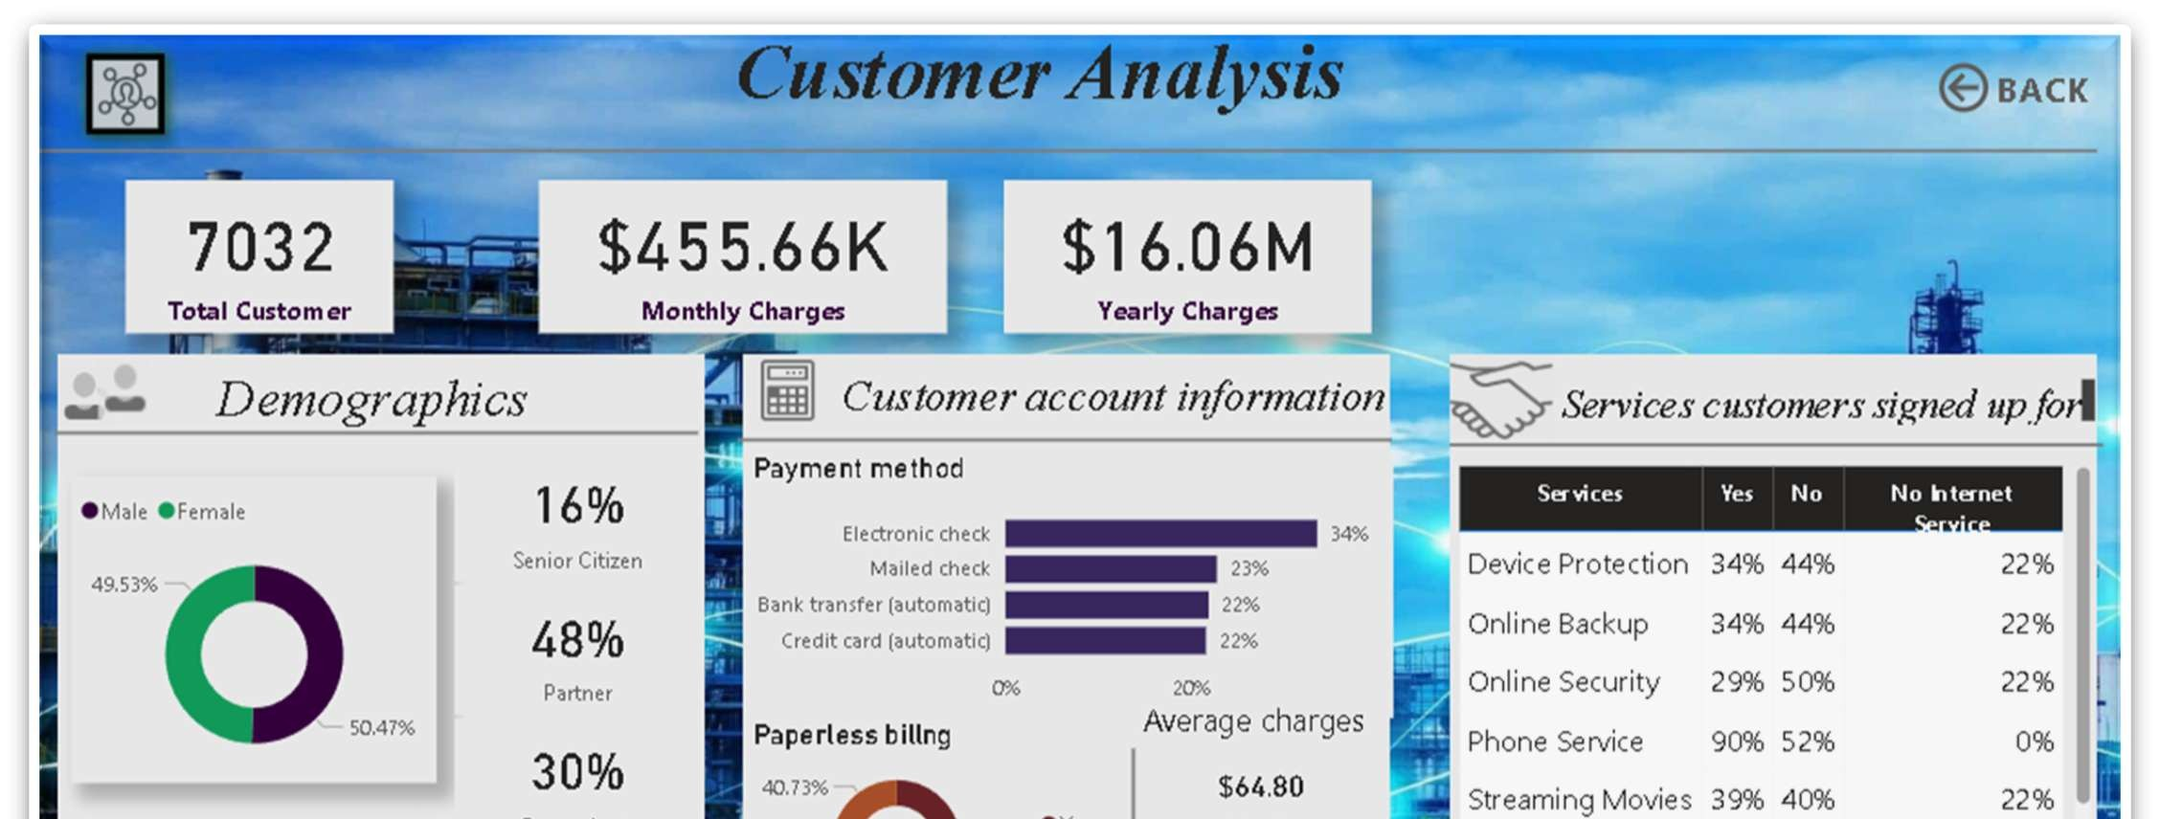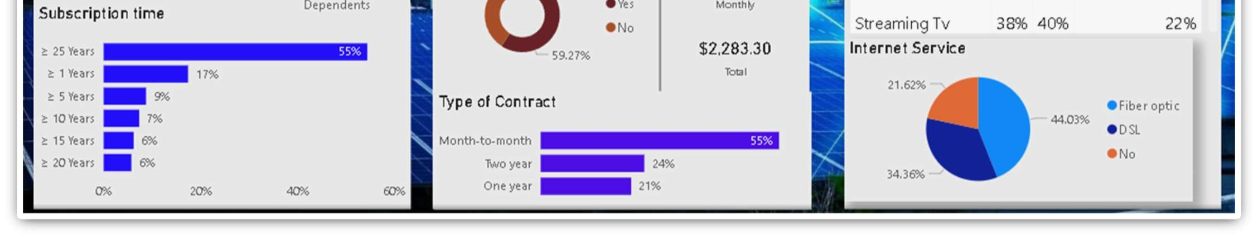

**📈 Visualization Development:**

**Key Performance Indicators (KPIs):**

* **Total Customers:** 7,032
* **Monthly Charges:** $455.66K
* **Yearly Charges:** $16.06M

**Demographics Insights:**

* **Gender Split:**
* Female: 50.47%
* Male: 49.53%
* **Senior Citizens:** 16% of the customer base.
* **Partner Status:** 48% of customers have a partner.
* **Dependents:** 30% of customers have dependents.
* **Subscription Time Breakdown:**
  + ≥ 25 years: 55% (Majority)
  + ≥ 5 years: 17%
  + ≥ 10 years: 9%
  + ≥ 15 years: 6%
  + ≥ 20 years: 6%

**Customer Account Information:**

* **Payment Methods:**
  + Electronic Check: 34% (Most used)
  + Mailed Check: 23%
  + Bank Transfer (Automatic): 22%
  + Credit Card (Automatic): 22%
* **Paperless Billing:**
  + Yes: 40.73%
  + No: 59.27% (Majority still use traditional billing)
* **Average Charges:**
  + Monthly: $64.80
  + Yearly: $2,283.30
* **Type of Contract:**
  + Month-to-Month: 55% (Most common but highest churn risk)
  + Two-Year: 24%
  + One-Year: 21%

**Services Customers Signed Up For:**

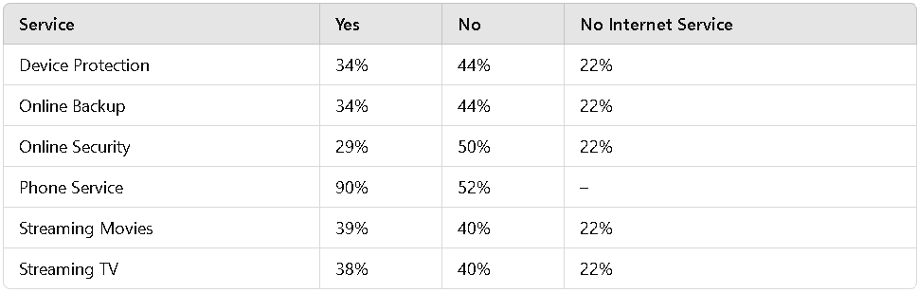

**Internet Service Distribution:**

* **Fiber Optic:** 21.62%
* **DSL:** 44.03% (Most popular)
* **No Internet:** 34.36%

**Key Insights and Recommendations:**

1. **High Churn Risk in Month-to-Month Contracts:**
   * 55% of customers are on a **month-to-month** plan. Offering incentives for longer contracts could reduce churn.
2. **Payment Method Optimization:**
   * **34%** use **Electronic Check**, which may lead to higher churn. Encourage customers to switch to **automated** payment methods for convenience.
3. **Service Adoption Opportunities:**
   * Services like **Online Security (29%)** and **Device Protection (34%)** have **low adoption**. Bundle these services or offer promotions to drive uptake.
4. **Internet Service:**
   * **DSL** dominates (44.03%), but **Fiber Optic** has room for growth. Promote **faster** and **more reliable** Fiber Optic service to encourage upgrades.
5. **Paperless Billing:**
   * With **59.27%** still using **non-paperless billing**, there is potential to **digitize** more customers through targeted campaigns.

**3.** **Not Churn Customer Risk Analysis Dashboard Overview:**

This dashboard analyses customer retention, categorizing customers based on their churn risk and identifying key factors that contribute to customer retention and churn.

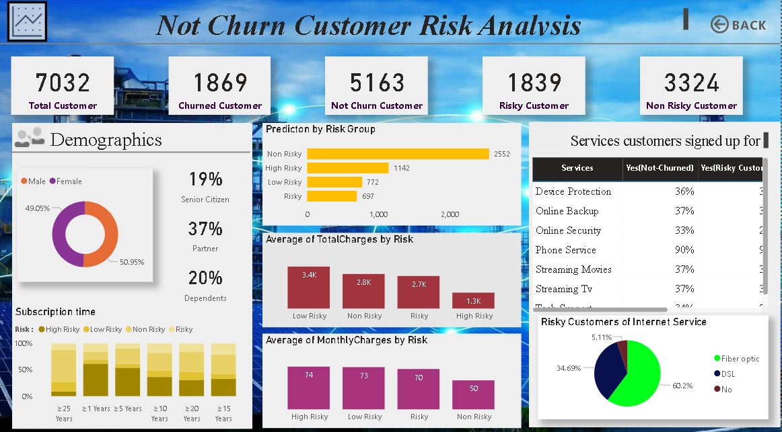

**📈 Visualization Development:**

**Key Metrics:**

* **Total Customers:** 7,032
* **Churned Customers:** 1,869
* **Not Churned Customers:** 5,163
* **Risky Customers:** 1,839
* **Non-Risky Customers:** 3,324

**Demographics Insights:**

* **Gender Split:**
  + Female: 50.95%
  + Male: 49.05%
* **Senior Citizens:** 19%
* **Partner Status:** 37% have a partner.
* **Dependents:** 20% of customers have dependents.
* **Subscription Time Breakdown by Risk Group:**
* Customers with longer subscription times (≥ 25 years) are generally at **low risk**.
* Higher risk customers are more likely to have **shorter subscription durations**.

**Churn Risk Prediction:**

* **Non-Risky Customers:** 2,552 (Most stable)
* **High-Risk Customers:** 1,142 (Most likely to churn)
* **Low-Risk Customers:** 772
* **Risky Customers:** 697

**Average Charges Based on Risk Group:**

* **Total Charges:**
* **Low Risk:** $3.4K
* **Non-Risky:** $2.8K
* **Risky:** $2.7K
* **High-Risk:** $1.3K
* **Monthly Charges:**
* **High-Risk:** $74
* **Low-Risk:** $73
* **Non-Risky:** $70
* **Risky:** $50

**Insight:**

* Customers with higher total charges tend to be at **lower risk**.
* **High-risk customers have the lowest total charges**, indicating they may be using fewer services.

**Services Customers Signed Up For:**

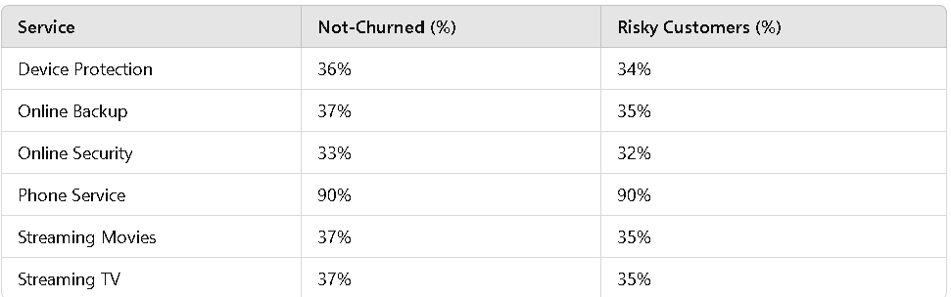

**Risky Customers & Internet Service Distribution:**

* **Fiber Optic:** 5.11%
* **DSL:** 34.69%
* **No Internet Service:** 60.2% (Majority)

**Insight:**

* **Most risky customers do not have internet service (60.2%)**, suggesting an opportunity to **convert them into internet service users**.
* Customers using **Fiber Optic are the least risky**, indicating that **high-speed internet contributes to customer retention**.

**Key Insights & Recommendations:**

**1.High-Risk Customers Have Lower Total Charges:**

* Consider **upselling additional services** to increase their engagement and reduce churn.

**2.Service Adoption Can Reduce Risk:**

* Customers with **more services tend to be lower risk**. Offering **bundled packages or discounts** for multiple services may improve retention.

**3.Customers Without Internet Are at Higher Risk:**

* + Since **60.2% of risky customers do not have internet**, **target them with internet service offers** to increase retention.

**4.Subscription Length & Risk Relationship:**

* **Longer-tenure customers are less risky.**
* Providing **long-term subscription discounts** can encourage customers to stay longer.

**5.Higher Charges Indicate Lower Churn Risk:**

* Customers paying **higher total charges tend to stay longer**.
* Encouraging **value-added services** can **increase revenue while improving retention**.

**4.Q & A: THIS PAGE HAS Q&A SECTION:**

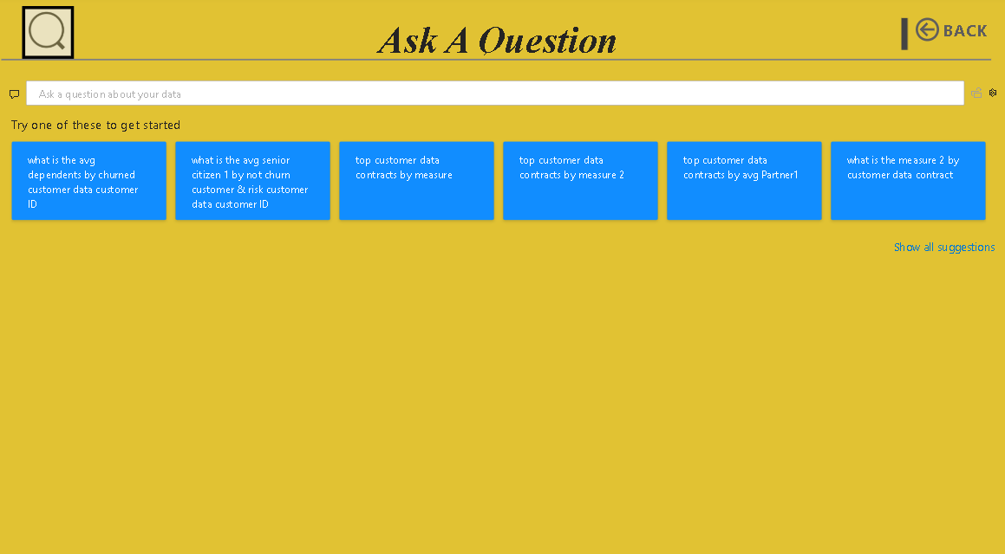

**Query Suggestions:**

1. What is the avg dependents by churned customer data customer ID
2. What is the avg senior citizen 1 by not churn customer & risk customer data customer ID
3. Top customer data contracts by measure
4. Top customer data contracts by measure 2
5. Top customer data contracts by avg Partner1
6. What is the measure 2 by customer data contract

**Functionality:**

* Users can type custom questions related to the dataset or select from the suggested queries.
* The focus appears to be on customer data analysis, including measures like average dependents, senior citizen status, customer churn, and contract metrics.

**Observations:**

* The suggestions are slightly verbose and could benefit from improved phrasing for clarity.
* The color scheme features a mustard-yellow background with blue suggestion cards, ensuring visual contrast.
* This interface likely helps users perform natural language-based data exploration.

**KEY FEATURES:**

1. **Customer Segmentation:**
   * Categorized customers based on demographics, service usage, and contract types.
   * Identified high-risk customer groups prone to churn.
2. **Churn Risk Analysis:**
   * Analysed patterns and behaviours leading to customer churn.
   * Segmented churned vs. loyal customers based on key attributes (e.g., tenure, monthly charges).
3. **Predictive Modeling:**
   * Leveraged machine learning models to predict churn likelihood.
   * Provided risk scoring to identify customers at high churn risk.
4. **Interactive Dashboards:**
   * Dynamic Power BI visualizations for real-time insights.
   * Drill-down features to explore customer attributes and churn patterns.
5. **KPI Tracking:**
   * Monitored key performance indicators such as churn rate, customer retention rate, and average revenue per user (ARPU).

**BUSINESS RECOMMENDATIONS:**

1. **Targeted Retention Campaigns:**

* Implement personalized offers for high-risk customers to improve loyalty.
* Provide exclusive incentives (e.g., discounts, loyalty rewards) for long-term customers.

1. **Service Improvement:**

* Identify and resolve common pain points (e.g., billing issues, network reliability).
* Improve customer support for better satisfaction and retention.

1. **Customer Communication Strategy:**

* Implement proactive communication for at-risk customers.
* Regularly survey customer satisfaction to address concerns promptly.

1. **Loyalty Programs:**

* Design loyalty programs to reward long-tenured customers.
* Implement referral bonuses to increase customer base.

1. **Data-Driven Decision Making:**

* Continuously monitor churn indicators and refine strategies.
* Use churn predictions to guide marketing and customer service efforts**.**

**KEY INSIGHTS:**

1. **High Churn Among Monthly Contract Customers:**

* Customers with month-to-month contracts exhibit a significantly higher churn rate.

1. **Impact of Charges on Churn:**

* Customers with higher monthly charges are more likely to churn.

1. **Service Quality Matters:**

* Poor service experiences (e.g., technical issues) correlate with increased churn.

1. **Demographic Factors:**

* Senior citizens and low-tenure customers are at a higher risk of leaving.

1. **Payment Method Influence:**

* Electronic check payment users have a higher churn rate compared to other methods.

**BUSINESS INSIGHTS DRAWN FROM THE DATA:**

1. **Contract Type Drives Retention:**

* Long-term contracts reduce churn likelihood; promoting annual contracts can improve retention.

1. **Pricing Sensitivity:**

* Cost-sensitive customers are more likely to switch providers; offering tailored discounts can mitigate this risk.

1. **Service Reliability:**

* Prioritizing infrastructure improvements in areas with high technical complaints can lower churn.

1. **Customer Support Efficiency:**

* Faster and more efficient customer service can enhance customer satisfaction and retention.

1. **Proactive Customer Engagement:**

* Engaging with customers before dissatisfaction grows helps to prevent churn.

**CONCLUSION:**

The 'Telecom Customer Churn Analysis Power BI Dashboard' provides a comprehensive view of customer behavior, helping to identify key drivers of churn. Through data-driven insights, the project emphasizes the importance of targeted retention strategies, customer-centric service improvements, and proactive engagement. By leveraging predictive analytics and interactive dashboards, businesses can reduce churn, enhance customer satisfaction, and drive long-term profitability.